ANSWERS WORKSHEET SIDE 1: 11.2

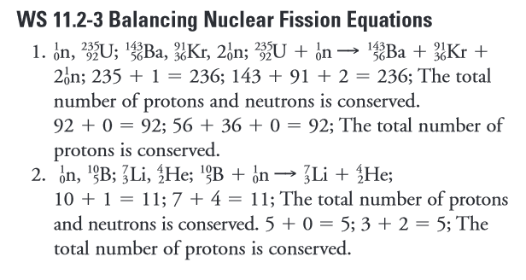
ANSWERS WORKSHEET SIDE 2: 11.5

