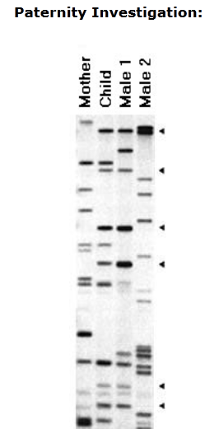
BIOTECHNOLOGY NOTES

Trying to determine who are the biological
______________________ of a child.

The DNA fragments in the child comes from the ________
and father.

A _______________ present in the child must come either
from the mother or from the father

To Do: Compare male 1 with the child then
male 2 with the child.

Interpretation:
The bands on the child's fragments are either found on
the mother or the male1.
__________ therefore is this father of this child.
None of the ____________ bands appear in the child

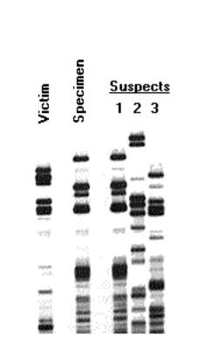
FORENSIC INVESTIGATION
A specimen of ____________ is taken from the victim
or the crime scene.
DNA samples are taken from the 3 ____________.
The bands are compared to associate the suspects
but to eliminate the victims ________ from the specimens

To Do: Compare victim with the specimen; then compare
Specimen with all 3 suspects

Interpretation:

Note that the bands on the specimen are ________________
by the bands on the Suspect _________.
This means that Suspect_______ was present at the crime scene.
The law will still require to prove a crime was committed
and then that Suspect ______committed the crime

Gene transfer involving plasmids, a host cell (bacterium, yeast or other cell), restriction enzymes (endonucleases) and DNA ligase. (2)
Outline / brief account of summary.
Stage 1: obtaining the __________ for transfer: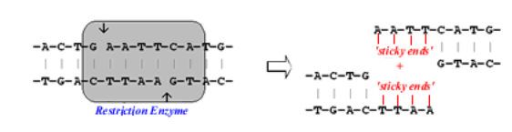Restriction enzymes are used to _____________ out the useful gene that is to be transferred.
Note the 'sticky ends' of unattached __________________ bonds.
Stage 2. Preparing a vector for the transferred gene:
Plasmids are small ____________ DNA molecules found in _________. These can be cut with the same ___________________ enzyme as above. This leaves the same __________________ 'sticky ends' in the plasmid. The plasmid can be cut at particular sites. These are called restriction ____________________ and some are named in the diagram.
Stage3. Recombinant DNA
(a) plasmid that will be the ____________ (b) plasmid cut at restriction site Pstl
(c) Source ___________________ cut with same restriction enzyme as plasmid to (d)
(e) Recombinant DNA (f) unaffected ____________________
