CEREAL BOX ACTIVITY: Teacher copy
Cereal Box Intro Activity: pre-assigned groups

Learning Objectives: What should students know and be able to do as a result of this lesson?
- Students will identify the surface and attributes of rectangular prisms that are measurable.
- They will measure and record the length, width, and height of four rectangular prisms.
- Students apply their knowledge of measurement by calculating real-life surface area problems.
Guiding Questions: Introductory Guiding Questions:
- What do you know about area?
- Give examples of where and how you observe area around you?
Guided Practice Questions:
- When you look at this part of the box what shape do you see? (Rectangle)
- What part of the box is that shape? (Front)
- What shapes make up the surface?
- What attributes of the shape are measurable (E.g. height, width, length)?
- Is it important to know how much an object holds, if you are calculating the surface area? Why or why not

- Students will now measure a section each. Students will write out the measurements similar to the picture / diagram shown.

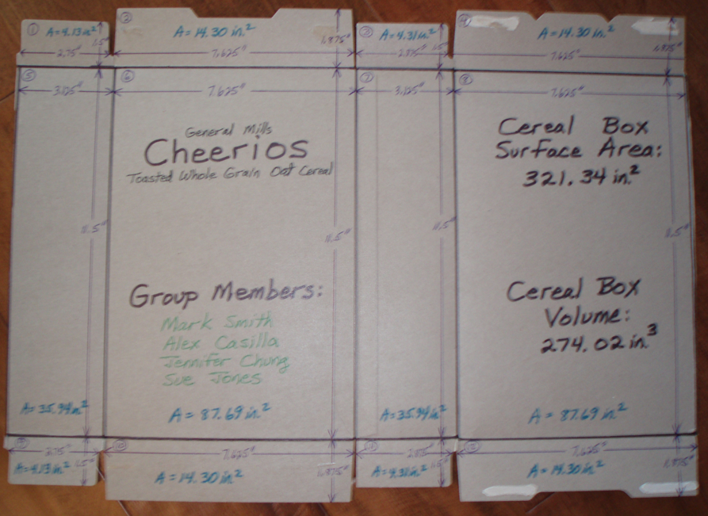

SOURCE: https://www.teachengineering.org/view_lesson.php?url=collection/duk_/lessons/duk_boxes_mary_less/duk_boxes_mary_less.xml

http://www.cpalms.org/Public/PreviewResourceLesson/Preview/29255

CEREAL BOX ACTIVITY:
Group work

Objectives:
- To identify the surface area and attributes of rectangular prisms that are measurable.
- To measure and record the length, width, and height of four rectangular prisms.
- To apply knowledge of measurement by calculating real-life surface area problems.
Group Questions:
- What do you know about area?
- How do you measure an object’s area?
- Give examples of where and how you observe area around you?
Extra Questions:
- What shapes make up the surface of the box?
- What attributes of the shape are measurable?
- Is it important to know how much an object holds, if you are calculating the surface area? Why or why not?
Assessment: see assessment page

over…….

Part II:
Once your group has a cereal box, each group member will choose a section to measure (some may be assigned more than one section). Please see my example at the front to help you with this and include length, width and calculated surface area right on your assigned section. PLEASE DRAW STRAIGHT AND ACCURATE LINES ON YOUR SECTION OF THE CEREAL BOX!
Now answer the following:
- How many sections / sides did you have to add up on your cereal box? ________
- As a group you are then to add up all surface areas and write out the total surface area of your cereal box here: _____________________________
- How much material was needed to make your box? ________________________

Bonus: How much volume of cereal would your box allow? Please elaborate your answer in the space provided below.

Team member’s names:

