Chapter 2 and 3 notes Name: ____________________________
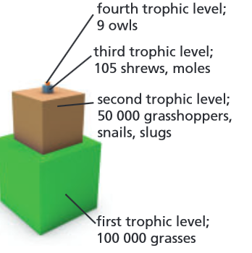
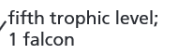
Biome: ____________________ Biome: ____________
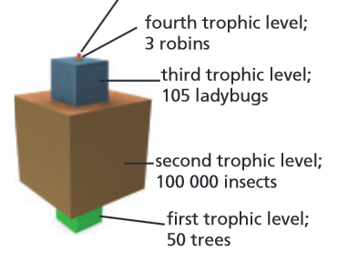

Pyramid of Energy
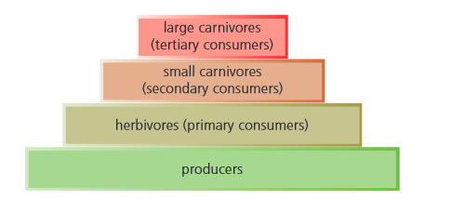
How much energy is lost between each trophic level? _____________ %
1 J

How much energy is passed along between each trophic level? ____%
1000 J

100 J

10 J

Question 1. A wolf that eats an elk cannot digest the antlers, hooves, teeth, hair, and bones. What do these materials represent?

A. matter available to omnivores B. energy available to herbivores
C. energy not available to carnivores D. matter not available to decomposers

Q2. Which of the following lists includes only abiotic factors?

A. pH, height of trees, water temperature B. temperature, annual precipitation, rock type
C. solar radiation, nutrient availability, number of decomposers D. salt concentration, stream flow rate, migration pattern of reindeer

Q 3. Which of the following characteristics distinguishes decomposers from other consumers?
A. the ability to produce food B. their position within a grazing food chain
C. the tendency to gain nutrition from dead organisms D. the ability to chemically break down organic compounds

Q 4. Which of the following processes could produce the energy necessary to support a community of organisms in a deep cave in the total absence of sunlight?
A. photosynthesis B. biodegradation
C. decomposition D. chemosynthesis

Q 5. List three different abiotic factors and describe a way in which each of them has had a direct impact on your day so far.

i)
ii)
iii)

A _______________ is a graphical way to show the monthly changes in temperature and precipitation throughout a year.
The line represents _________________ and the bar graphs represent __________________
Biome name: _________ Biome name: _____________
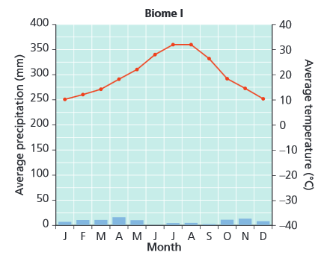
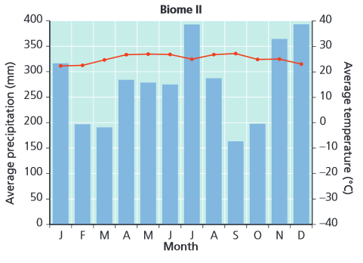

The long-term pattern of temperature and precipitation is called _______________. These long-term weather patterns are largely affected by _______________ on Earth. Particularly important are _______________ (the distance from the equator) and
___________________ (height above sea level).

Q 6. Provide two similarities and two differences between each of the following:

(a) desert and tundra
(b) climate and biome
(c) tropical rainforest and temperate rainforest
(d) boreal forest and temperate deciduous forest

Q 7. Which of the following is the best explanation for seasonal change?

A. circulation of ocean currents B. the daily rotation of Earth on its axis
C. warm, moist air falling near the equator D. the tilt of Earth as it orbits around the Sun

