Credit Cards Assignment 2 Name_____________________

Assume you are 19 – 21 years and making a yearly salary.
- Go to the TD bank website (https://www.tdcanadatrust.com/products-services/banking/index-banking.jsp)
Click on Credit card Selector. Use this online tool to choose a card best for you. Use the Snipping tool and snip the card you selected.
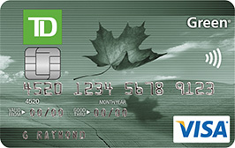

- Go to the CIBC website navigate to the credit card comparison. Compares 3 cards that might be good for you. Snip the page and copy it to this document.

- Which CIBC card works best for you? Explain.

For ex. CIBC Select Visa Card, easiest to afford, suits my needs the most.

- Go to the Bank of Montreal site and the credit card page. Choose the Preferred rate Card and paste a pic of it on this document.

- Using this card you buy a $3500.00 car stereo. And pay it back after 180 days. How much interest will you owe? Show your work!
The rate is calculated daily use A = P(1+r/n)^{nt} .

- Go to the Scotia bank site and the credit card selector. Compare 3 cards and paste your selection to this document.

- Choose the best credit card from all of these banks and explain why you chose that particular card.

