Density Introductions Name: ______________________

- a) Draw the tank that you see at the front of the room in the space provided below:

b) Describe what you think is happening and WHY?
Density formula

Density = __________

Density equals the ________________ per unit of _____________.

- Mass of can of Coke = __________ g Mass of can of Diet Coke = ___________

- The regular Coke has more ___________ for the same volume, so the density of the regular coke is ____________ higher

Density describes how ______________________ the particles are in a material.

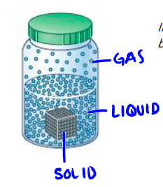
Looking at the diagram to the left describe the spacing of the particles in the solid block, the liquid, and in the gas.

Solid: ___________________________

Liquid: _________________________

Gas: ___________________________

Temperature application to density

Most substances are more dense in their _________ form than in their liquid form.
- Knowing this, how do you think temperature and density are related?

- As temperature increases density ____________________

- What is the one exception to this rule? ________________________________

Density of Water = 1.00 g / cm

Fluids that do not mix will form layers based on density!
- Fluids with a _______________ density 'float' on top of fluids with a higher density.
- If a fluid has a density less than water (1.00g/cm ) it will float

