Optional FOOD DESIGN LAB

Name the title of your Food lab: _______________________________________

Follow all information found on the handout titled “Lab Report Template”

You are responsible for the following:
- Complete a lab report including data table, data analysis, conclusion and evaluation
- Film your lab and in this discuss your results
- Send Mr. Bodnar a link to your video and hand in your completed lab report by:
Due Date: November 28th/2013

You will be assessed on the following:

Criterion D: Scientific Inquiry
Students are expected to design and carry out scientific investigations independently. Students should be able to (i) state a problem that can be tested by an investigation; (ii) formulate a suitable hypothesis; (iii) identify and manipulate variables; (iv) plan an appropriate investigation including the method and materials; (v) evaluate the method.
Achievement level | Descriptor
0 | The student does not reach a standard described by any of the descriptors given below.
1–2 | The student attempts to define the purpose of the investigation and makes references to variables but these are incomplete or not fully developed. The method suggested is partially complete. The evaluation of the method is either absent or incomplete.
3–4 | The student defines the purpose of the investigation and provides an explanation/prediction but this is not fully developed. The student acknowledges some of the variables involved and describes how to manipulate them. The method suggested is complete and includes appropriate materials/equipment. The evaluation of the method is partially developed.
5–6 | The student defines the purpose of the investigation, formulates a testable hypothesis and explains the hypothesis using scientific reasoning. The student identifies the relevant variables and explains how to manipulate them. The student evaluates the method commenting on its reliability and/or validity. The student suggests improvements to the method and makes suggestions for further inquiry when relevant.

Food that you may be able to use for the rates of reaction: (CIRCLE YOUR CHOICE)
- Eggs
- Cheese
- Butter
- Dough
- Fruit
- Muffin / cake mix (please get permission first)
- French toast
- Other: ____________________
- Look here for ideas: http://www.juliantrubin.com/foodprojects.html
Notes:

Lab Report Cheat Sheet
Now your job is to design a lab of your own.

You are to design a lab which will address one of the following rates of reaction factors:

What 4 factors do you think can speed up a reaction (what makes it easier for atoms to collide)?
- ____________________
- ____________________
- ____________________
- ____________________
Remember we are looking for Reliability and Validity when you accomplish this lab report.
Cover Page: Title of lab, Date of submission, Name of Teacher, Your name, Number of pages
Title: (what factor are you researching?) ____________________________
Background Theory ( optional ):
-
Aim: What are you trying to find and how are you going to find it?
-
Hypothesis: Write down what you think will happen in your experiment and why.
-
Variables:
Controlled Variable: all variables that you will keep the same throughout
-
Independent Variable: what will change in the experiments and how it will be measured.
-
Dependent Variable: what you will MEASURE and how it will be measured.

Materials
-
-
-
Method:

Diagram: A clearly labeled diagram showing all of the apparatus you will use “in action”.
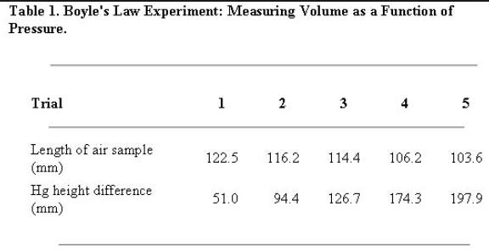
Results / Data Collection (very important!)

Data table examples:
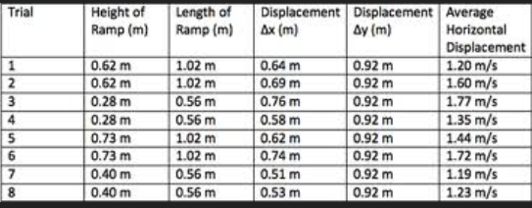

Data Processing
- Show your calculations and / or statistical analysis.
- Table the calculated values including values, units and uncertaintities.
- A graph may be a good way to interpret your results.
- Label each graph or table appropriately (Title, values, Fig. 3; Fig A, etc.)

Conclusion: Summarize what you found and how you know it using your graph and table of results.

Evaluation
A/

B/

