Design to Specs’ / Critical challenge: Design a drinking box.

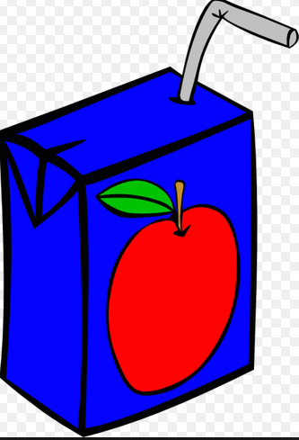
Step 1:

Task: Design a drinking box that will incorporate the
following specifications.

Issue/ Agenda: You are to teach others how to
calculate surface area.

Colour: Between 2 and 3 colours only

Message: To inform the customer how surface area is
calculated. You can create any symbol, equation,
or message in order to communicate this. This message must
be on at least one side of your drinking box.

Design: must be on all 6 sides of your box drawing!

Step 2: (Extension)

Now go back to your group and show each other your idea that you have designed on paper. Discuss what you as a group would like to see as your drinking box creation. As a group, you are now to construct your own drinking box incorporating the Design specs' that you have followed in Step 1.

Shape: The shape and size of your drinking box is completely up to your group. However, you must not exceed a total surface area of ___________________. You may use as much paper as you wish.

DRINKING BOX DESIGN CHALLENGE: Draw / sketch your ideas in the following boxes provided

Back

Front

Top

Bottom

Side 2

Side 1
ASSESSMENT

Category | Poor ( Below 50%) | Satisfactory (50% + ) | Good (72% +) | Excellent (86%)
Creativity | No attempt | Weak input | Appropriate | Great ideas, clever descriptions, good use of colour
Group participation | Negative influence, unruly behavior, | Not much input, more socializing than work | Good use of time, the occasional direction is needed by teacher, | Full participation, staying on task, leading through example
Math Calculations – surface area, measurements | Nothing completed | Many errors are evident, but attempt is made; messy output, hard to read in certain areas | One or two errors,  Lines not drawn accurately, messy in place | Appropriate units, correct additions, total surface area believable, understanding is evident
Final design / creation | Very little accomplished | Satisfactory attempt | Good product, lacking all information / categories, a few places where misunderstanding is evident | Eye catching, informative, matches up to specs, full effort, understanding the task well

