Drosophila lab Student notes
Reference website: http://www.biologycorner.com/fruitflygenetics/
A misconception explained:
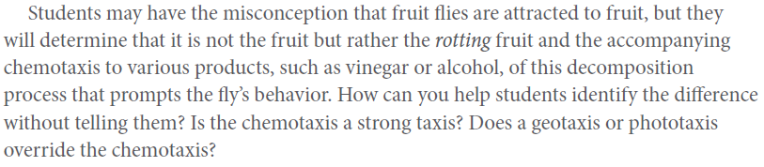
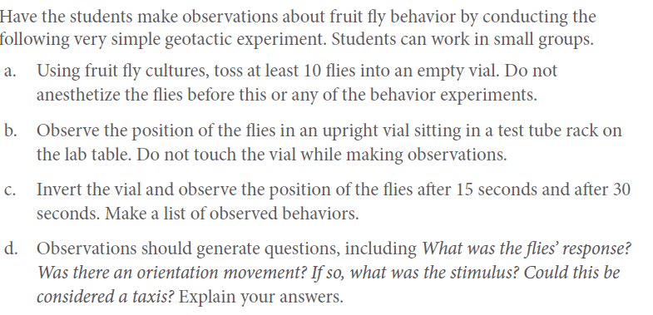
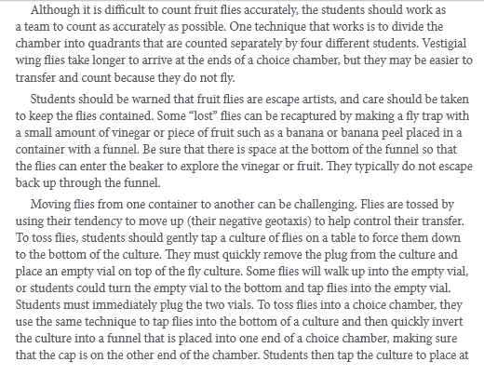
Skill development: Is it a male or a female?
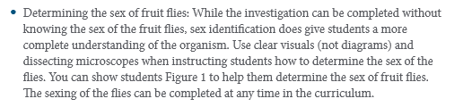
What is expected of you between today and Wednesday’s class:
