EVOLUTION INTRO NOTES Name:
Evolution is the __________________ change in the heritable characteristics of a ___________.
Darwinian Evolution is not simply based on _________________ selection but was in fact a composition of at least five different 'sub theories':
1. Evolution: that all life is and has been perpetually _______________________. This contrasts strongly with notions that all forms of life are constant an unchanging.
2. Common descent: that all living things share a ___________________ ancestor if the traced back far enough.
3. Gradualism: that evolutionary change takes places ____________ and ________________. This contrasts with saltation in which changes are sudden and extreme.
4. Multiplication of species: the diversity of life is a consequence of speciation. Populations _____________________ to locations and becoming reproductively _________________ from other populations.
5. Natural selection: a two stage process in which there is:
  - 1. __________________________________________________________

  - 2. ___________________________________________________________

Outline the evidence for evolution provided by the fossil record, selective breeding of domesticated animals and homologous structures
- Fossil: A fossil is the ancient preserved remains of an organism. The fossil can be dated from the age of the ____________ formation. Sequences of fossil can show the gradual change of an organism over geological time. ________________ fossil records are rare with most containing large time gaps until subsequent discoveries are made.

- Homologous: All of life is connected through ______________________ history and consequently those organisms more closely connected might reasonably be expected to share common structures or ____________________. Group of organisms closely related share a common form or derived trait which has been inherited from the common ancestor.

In homologous structures it is normal to find that parts of the structure will be ________________________, enlarged or ______________________ (vestigial).
Divergence: The pentadactyl limb structure shows adaptation and modification from a ___________________ limb (ancestor) structure.
Convergence: Two organisms with different ancestors have a limb structure that fulfills the _____________________ function but has evolved from __________________ origins.
Example: Wing of a bird and the wing of an insect.
a) Humerus
b) Radius
c) Ulna
In each example the bones are modified and adapted to the locomotion of the animal.
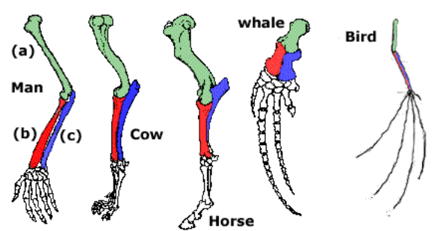
Selective breeding: man has selectively breed animals and plants for thousands of years. If an animal ____________________ a characteristic that is considered useful or valuable then this animal is selected for breeding. The hope then is that this characteristic will be present in the next generation and at a higher ________________ than before. In subsequent generations it may even then be possible to select from an even more _______________ characteristic.
A Thought experiment: Selection of high milk yields in cows.

