Feb 17th Notes Name:

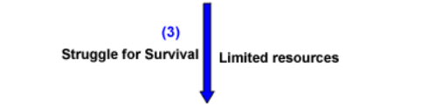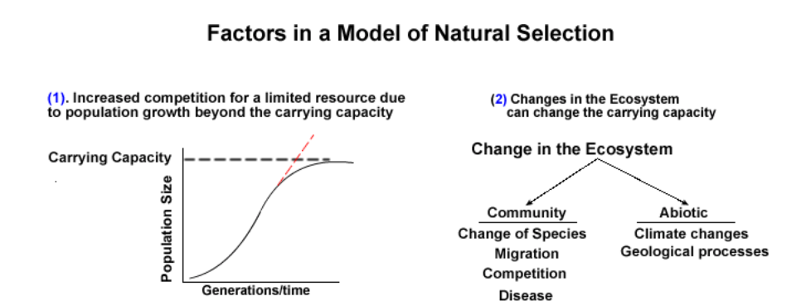

**3 types of selection:**

**i)**

**ii)**

**iii)**

SELECTION PRESSURES