Evolution Lecture #2 Name: _____________________

Population growth produces more offspring than the ____________________________ capacity of an environment can support.

Offspring/population compete for limited resources (______________________ competition)
Some individuals have characteristic (or a combination ) that give them a _______________ advantage. These individuals are consequently 'fitter' in terms of freedom from disease, food availability etc. These individuals are more likely to successfully ______________________ (offspring survive)
Through inheritance of the genes for these advantageous characteristics the ____________________ of these characteristics become greater in the next generation. The alleles for the ____________________ characteristic becomes more frequent in the population

Draw a sigmoid growth curve here:

Populations of a species show ____________________ - this means differences in ________________.
Variation shows two basic patterns.

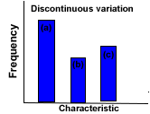
This type of variation is called discontinuous.
There are distinct classes of ________________
e.g. __________________________ of a human population
Discontinuous variation usually indicates the condition is controlled by one to two genes.

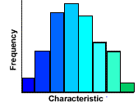
This type of variation is called ________________ variation with no distinct classes but a complete range of the characteristic
e.g. __________________________ in a forest
Continuous variation like this normally indicates a _____________________ condition or multiple ___________

Now….how can this relate to what we’ve studied from Genetics?

The sources of genetic variation in a population are:

i)

ii)

iii)

