Name:
What is the difference between Fission and Fusion Nuclear Reactions?

Nuclear Fission: the process of splitting nucleus into two smaller nuclei

By throwing a neutron at Uranium-235, you get - Nuclear Bomb! OR Nuclear Power Plant

Nuclear fusion is the fusing or joining of two small nuclei to make one larger nucleus.THE SUN!

2 examples:
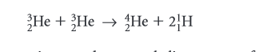
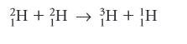
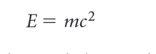

E=is the energy (measured in joules),
m = the mass (measured in kilograms)
c = the speed of light (3.0 x 10 m/s).

The mass of the products produced in a nuclear reaction is less than the mass of the original materials. The missing mass appears as energy!

4.5 billion times more nuclear energy is available!
Energy is released as the kinetic energy = emitted radiation and daughter nuclei = turns into thermal energy (heat) then into electrical energy (turbines)

A fission bomb, which is also called an atomic bomb, uses uranium or plutonium stored at a mass that is less than the critical mass. Critical mass is the mass of radioactive material required to sustain the reaction.

p. 317 # 1, 7, 9

The energy produced from individual nuclear fission reactions is very small.
To produce a useful amount of energy, many fission reactions need to occur
simultaneously.

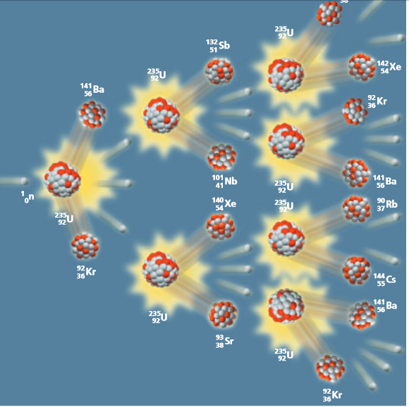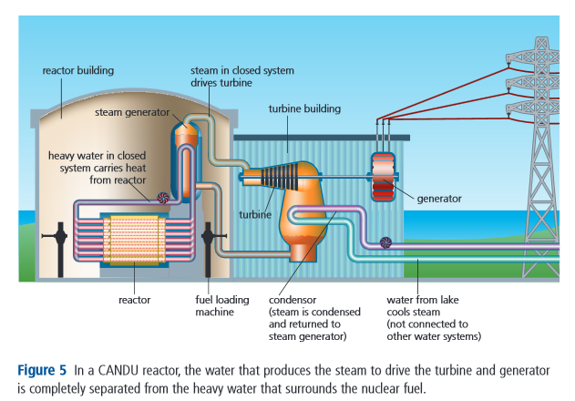
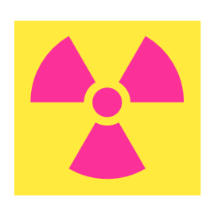
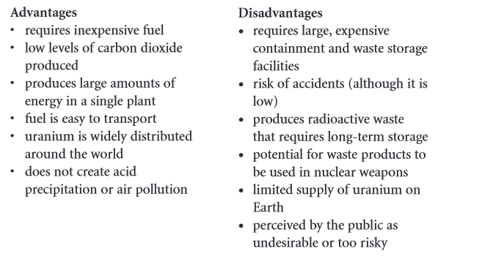
p. 323 # 5, 9 , 11

