Answers:

- View the Dragons below. The winged trait is dominant.
7 of 21 are aa = q² = .33
q = .58
p = .42
p² = .18
2pq = .49--> number of heterozygotes
- You have sampled a population in which you know that the percentage of the homozygous recessive genotype (aa) is 36%. Using that 36%, calculate the following:
A. The frequency of the "aa" genotype. .36
B. The frequency of the "a" allele. .6
C. The frequency of the "A" allele. .4
D. The frequencies of the genotypes "AA" and "Aa." .16 and .48
E. The frequencies of the two possible phenotypes if "A" is completely dominant over "a." .36 will show recessive trait, .64 will show the dominant trait

Hardy Weinberg Problem Set
p² + 2pq + q² = 1 and p + q = 1
p = frequency of the dominant allele in the population
q = frequency of the recessive allele in the population
p² = percentage of homozygous dominant individuals
q² = percentage of homozygous recessive individuals
2pq = percentage of heterozygous individuals
1. View the Dragons below. The winged trait is dominant.
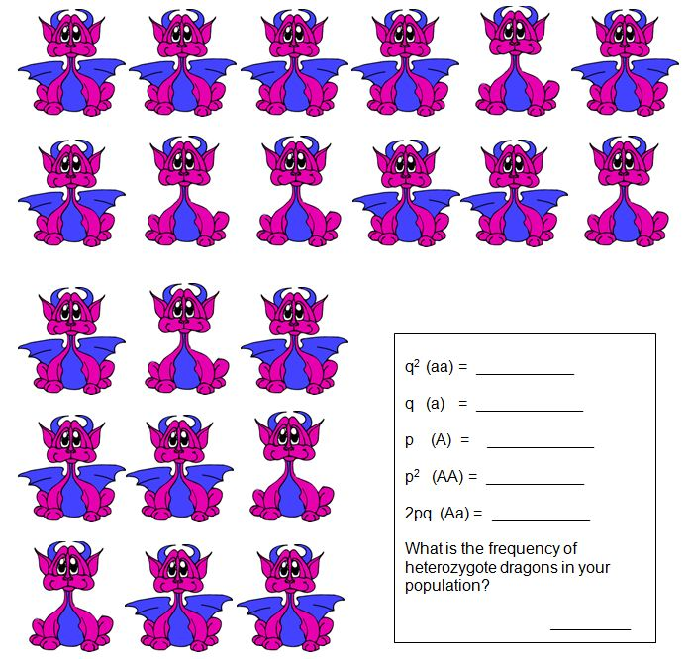

- You have sampled a population in which you know that the percentage of the homozygous recessive genotype (aa) is 36%. Using that 36%, calculate the following:
A. The frequency of the "aa" genotype.
B. The frequency of the "a" allele.
C. The frequency of the "A" allele.
D. The frequencies of the genotypes "AA" and "Aa."
E. The frequencies of the two possible phenotypes if "A" is completely dominant over "a." ____________will show recessive trait, ________________ will show the dominant trait

