Start out at our class site!
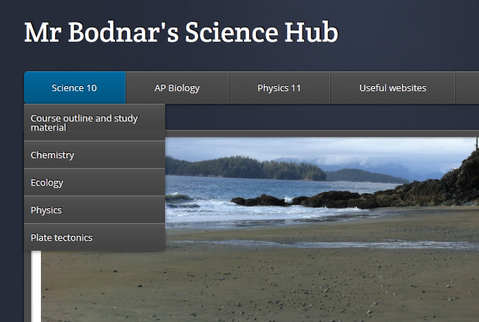
Then…..click on…
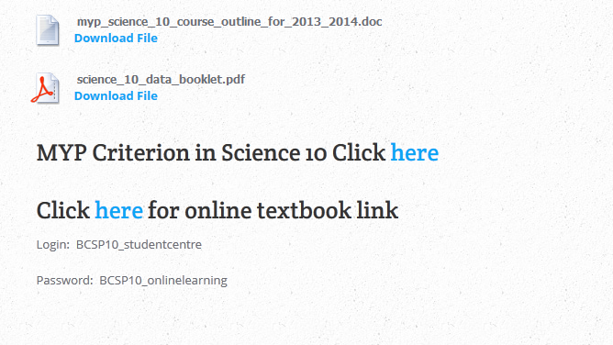
Remember to copy and paste the password!

Then….click student Centre…..fill in the User Name and Password with the correct info

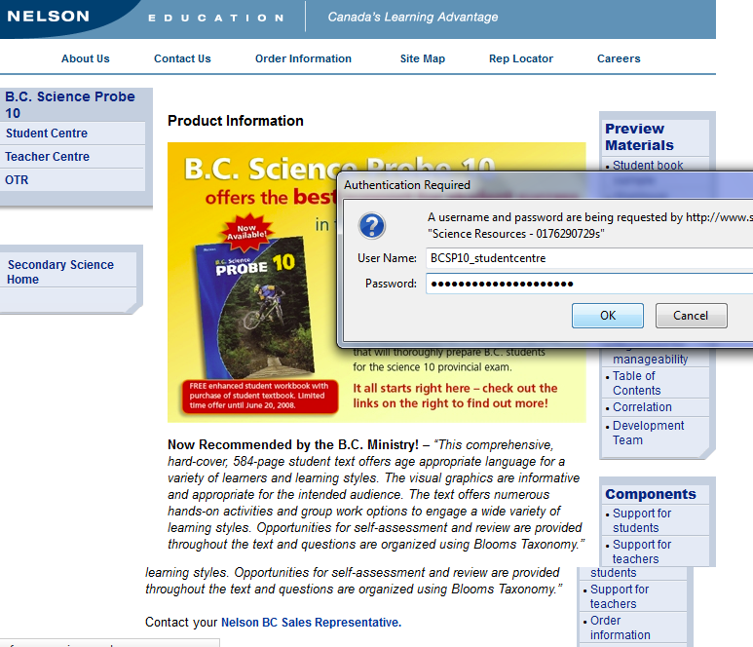

Then you get to this…..Click on B.C. Science Probe 10
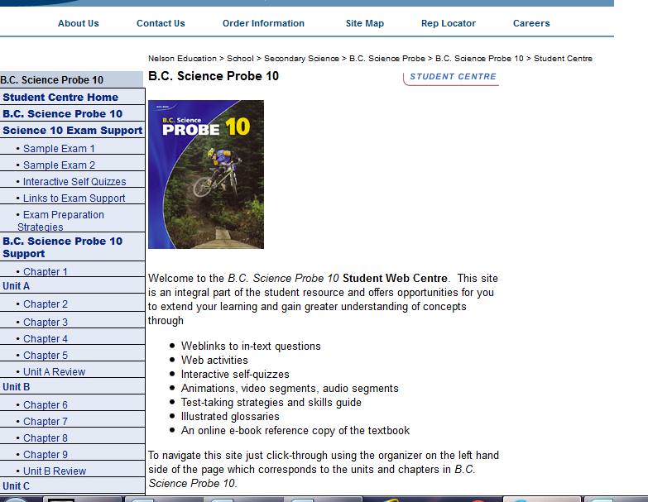

Then click here…..
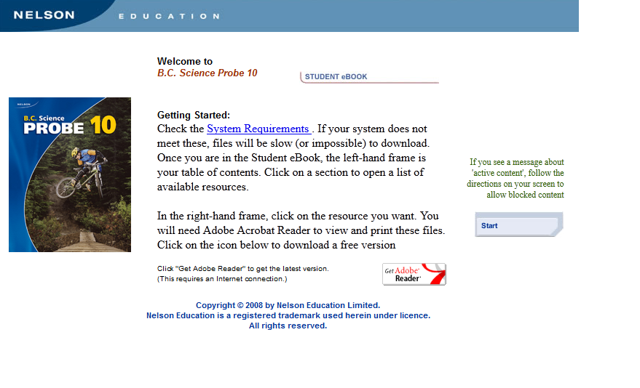

And you should get……boom! You’re welcome.
