Grade 9 Mathematics
Rutland Secondary School Math 9
TEACHER: Geoff Bodnar
Email: geoffrey.bodnar@sd23.bc.ca
Website: bodnarrutland@weebly.com

DESCRIPTION OF COURSE:

Learning to solve problems is the main reason for studying mathematics. In today’s technological world, many people are finding that their job demands higher levels of mathematical ability than ever before.
Mathematics 9 is made up of topics on understanding, explaining and solving algebraic equations, along with some more abstract algebraic concepts. Students will also explore surface area and the idea of similarity and scale diagrams. An emphasis on understanding exponents and powers, square roots and rational numbers is also included.
Depending on graduation plans and academic achievement, some students will continue on into Foundations and Pre‐Calculus 10 while others will enter into Apprenticeship and Workplace Mathematics 10.
Course Structure
The material for this course will be delivered in a variety of ways, the intention being to address the different learning style preferences of students enrolled in the course and at the same time, utilize suitably proven teaching methods to ensure successful concept development. It is expected that all students will endeavor to work equally well independently and/or collaboratively.
Textbook assignments will be given on a regular basis. On-going student self-assessment will be an integral part of this course as students learn to take responsibility for their own learning.
Learning Outcomes
Learning outcomes are statements of what students are expected to know and be able to do by the end of the course. Below is a summary from the Ministry of Education. A complete list of the outcomes can be found at: http://www.bced.gov.bc.ca/irp/pdfs/mathematics/2008math89.pdf

Math 9 Syllabus

Chapter 2 – Exponents
- Exponent laws, showing variable bases, Powers of Ten

Chapter 1 – Square roots of Perfect Squares

Chapter 3 – Rational numbers]
- What are rational numbers? Adding and subtracting rational numbers
- Multiplying and dividing rational numbers
- Order of Operations with Rational numbers

Chapter 4 – Linear Relations
- Writing equations
- Using graphs to estimate values

Chapter 5 – Polynomials
- Adding and subtracting polynomials
- Modelling polynomials

Chapter 6 – Linear Equations and Inequalities
- Solving equations using inverse operations
- Solving equations using Balance strategies
- Introduction to linear Inequalities

Chapter 1 – Surface areas
- Of objects made from right rectangular prisms

Chapter 7 Similarity and Transformations
- Scale diagrams and enlargements
- Scale diagrams and reductions
- Similar polygons
- Similar triangles
- Reflections and Line Symmetry

Chapter 9 – Probability and Statistics

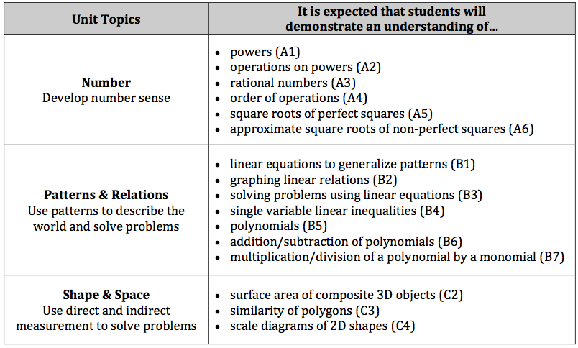

Course Grade
Students will be assessed and evaluated on an individual basis using a variety of the following techniques:
Evaluation:

Tests: 50%
Quizzes: 25 %
Projects / Assignments: 25%

  - Classroom Expectations:
- Respect your teacher and your classmates.
- Keep the classroom clean by removing all garbage and recyclables.
- Arrive to class on time. You are a distraction when you are late. You will also miss important feedback on your progress towards the learning outcomes and may miss part of the lesson.
- Special Note on Attendance While it is understandable that students will get sick or have family emergencies, the original classroom experience can never be 100% duplicated. If possible, appointments should not be booked during this class as an absence will affect a student’s level of understanding of the material. It is the student’s responsibility to catch up on anything missed during an absence. Students should check the website, complete what can be done of the missed work, and Mr. Bodnar the day they are back at school. Missed assessments must be completed as soon as possible.

