17.5 MUTATIONS
Gene mutation is a change in the base sequence of an ________________________.
The changed base sequence may produce a different _______________ sequence in the protein translated.
The changed base sequence may not change the _______________ because of the degenerate nature of the genetic code.
The expression of the mutated gene may or may not be beneficial to the organism.
Substances that cause mutation are called _____________ and include chemicals and radiation.

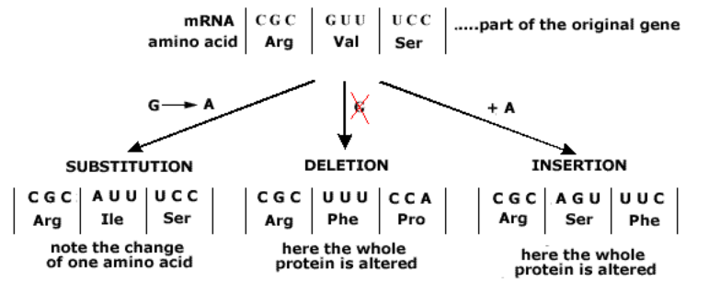
Missense:
Nonsense:

16.3 (see: http://www.youtube.com/watch?v=9kQpYdCnU14&noredirect=1)
Packaging 6 meters of DNA into a nucleus……how is it done?

