Predict the genotypic and phenotypic ratios of offspring of monohybrid crosses
Name:
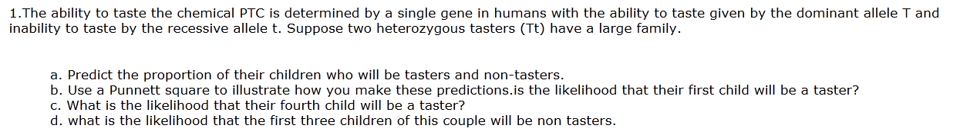

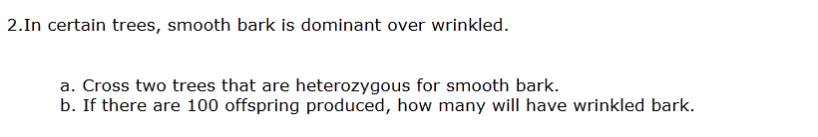

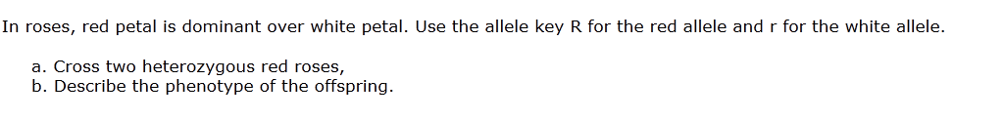
3.

