Lesson Title: Volume and Density Introduction

Date: Dec. 3rd 2015
Name: Geoff Bodnar

Subject: Science 9
Grade(s): Grade 9

Curricular Competencies: Students are expected to be able to do the following:

Questioning and predicting
- Demonstrate a sustained intellectual curiosity about a scientific topic
- Make observations aimed at identifying their own questions, including increasingly abstract ones, about the natural world

Planning and conducting
- Select and use appropriate equipment, including digital technologies, to systematically and accurately collect and record data

Processing and analyzing data and information
- Seek and analyze patterns, trends, and connections in data, including describing relationships between variables and identifying inconsistencies
- Use knowledge of scientific concepts to draw conclusions that are consistent with evidence

Rationale: We have recently been looking at mass and how to both measure and record it in various forms. The next stage on this journey is volume, an important concept which ties in very well with our current math unit on surface area, squared numbers and square roots of perfect and non-perfect squares. It is an important concept to cover in that it allows for students to experience techniques involving graduated cylinders, reading a meniscus and the displacement of water of an object – including Archimedes story (see picture below). We will be continuing to develop reasoning skills and analyzing data patterns in order to draw conclusions that are consistent with the evidence. After volume, we will put it literally under mass, forming the formula to find Density (see class notes with questions to follow).

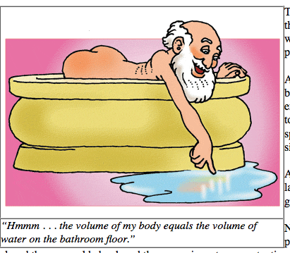

Key words: volume, displacement, cubed, beginning and ending water levels, density, mass, meniscus, graduated cylinder, Archimedes, regular and irregular shaped objects

Instructional Objective(s): To connect volume and mass to the Density equation; Review volume notes, how to measure volume of regular shapes, introduce volume of irregular shapes, introduce Density concept using a ‘Discrepant Event’ (see notes)

Pre-requisite Concepts and Skills: Volume, how to find it, how to read the meniscus on a graduated cylinder, the principle of displacement

Materials and Resources: graduated cylinders, water, various objects (regular and irregular shaped objects), table to record results, beakers of various sizes

Guided Practice: What activities or exercises will the students complete with teacher guidance?

- Small review of what a graduated cylinder and the meniscus means

- Archimedes Story; Facilitate a discussion as a class to determine how to measure an objects’ volume

- Take notes and fill in blanks on volume notes…. (see notes)

- Introduce the lab application, what to measure, where to find them and introduce partners / groups (pre-arranged groups)

- I will use a large graduated cylinder to ask the guided practice questions: What measurements make up the volume? What attributes of the shape are measurable? (E.g. height, width, length). What is volume useful for?

- Students will now get into groups and start measuring their 5 objects. Students will write out the measurements into the sections provided. I will walk around asking about things like meniscus, how to measure volume, what do we do when we have irregular shaped objects, etc.

- Swap assignments with another group and proceed to calculate volume of these objects….(see class notes)

- After checking the assignment, students will get back to their desks to witness the discrepant event – coke vs. diet coke and asked the questions what is happening here and why?

- Fill in the Density notes

- Quick exit quiz on way out – verbal quiz on mass, density and volume, or lab ideas

