Bean Experiment Lab Report

Name: ____________________________________________________________ Period_____________

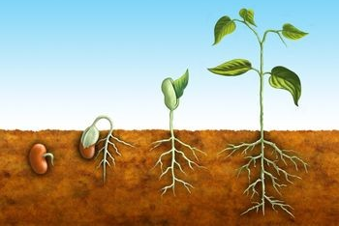
Grading Rubric/Outline:
See rubric attached!

Step 1: State the question or problem

__________________________________________________________________________________________________________________________________________________________________________________________________________________________________________?

Step 2: Form a testable hypothesis

If_____________________________________________________________________________Then________________________________________________________________________________________________________________________________________________________
Because________________________________________________________________________
Step 3: Perform an experiment

List Materials (include the greenhouse):_____________________________________________
__________________________________________________________________________________________________________________________________________________________________________________________________________________________________________
Independent Variable (what you change) in a complete sentence:

__________________________________________________________________________________________________________________________________________________________________________________________________________________________________________

Dependent Variable (what you measure) in a complete sentence:

__________________________________________________________________________________________________________________________________________________________________________________________________________________________________________

Controls:_____________________________________________________________________________________________________________________________________________________

Write the Procedure in complete sentences. Be VERY SPECIFIC:

Step 1:
__________________________________________________________________________________________________________________________________________________________________________________________________________________________________________

Step 2:
__________________________________________________________________________________________________________________________________________________________________________________________________________________________________________

Step 3:
__________________________________________________________________________________________________________________________________________________________________________________________________________________________________________

Step 4:

__________________________________________________________________________________________________________________________________________________________________________________________________________________________________________

Step 5:

__________________________________________________________________________________________________________________________________________________________________________________________________________________________________________
Attach more steps if necessary.

Step 4: Collect and Analyze Data

Your Data:

Bar Graph
Title: _________________________________________________________________

Y-axis Title
___________________________________________________________________________________________

X-axis Title: ______________________________________________________________________

Step 5: Draw Conclusions

My hypothesis was (circle one) correct incorrect

because__________________________________________________________________________________________________________________________________________________________________________________________________________________________________________________________________________________________________________________.

Step 6: Communicate Results

Write a paragraph overview of your experiment to share with the class. Include answers to all of the following: How reliable is your data? How can your data be useful to others? What would you change if you could do the experiment again? What went right and what went wrong?

__________________________________________________________________________________________________________________________________________________________________________________________________________________________________________
__________________________________________________________________________________________________________________________________________________________________________________________________________________________________________
__________________________________________________________________________________________________________________________________________________________________________________________________________________________________________
__________________________________________________________________________________________________________________________________________________________________________________________________________________________________________

