Tuesday November 19th Unit Quest

‘Stuff’ you should know….
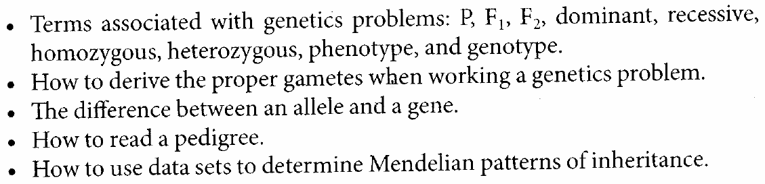

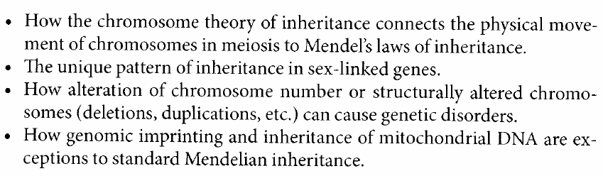

Also….
- Examples of sex linkages
- Why sex linkage occurs
- Brief outline of meiosis stages (no pictures to be drawn)
- 2 Data Analysis Questions

